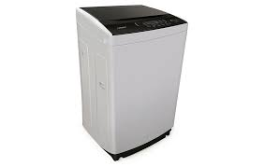

DW 255 ES

* Triple Water Fall Technology
* Extreme Plus Air Dryer
* Pro Fabric Drum
* Glass Door
* **Rs.45,800**